Tommaso Facchin
STA510 – Assignment 1 report

Problem 1

a) The pdf is valid because is non negative and integrate to 1.
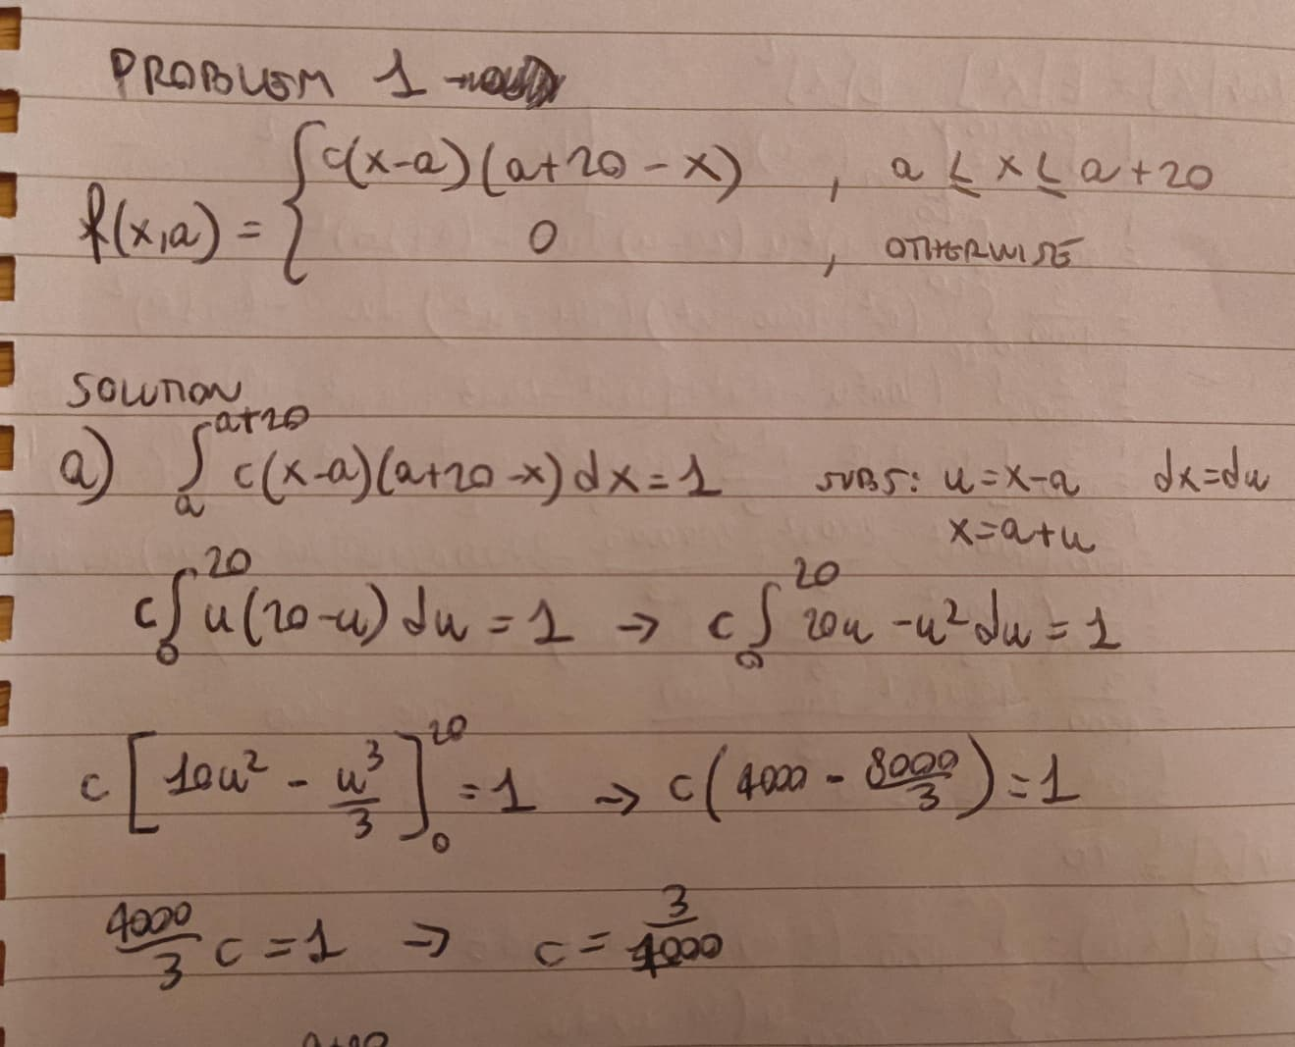

b)
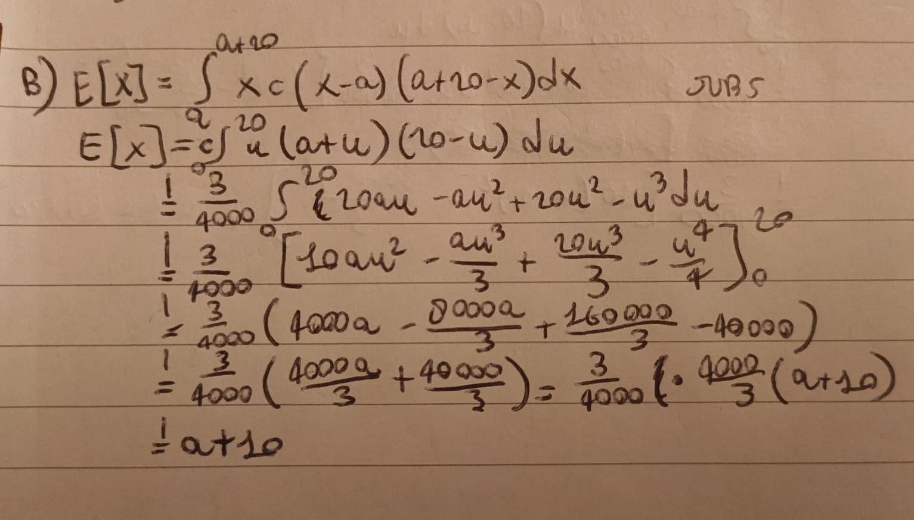

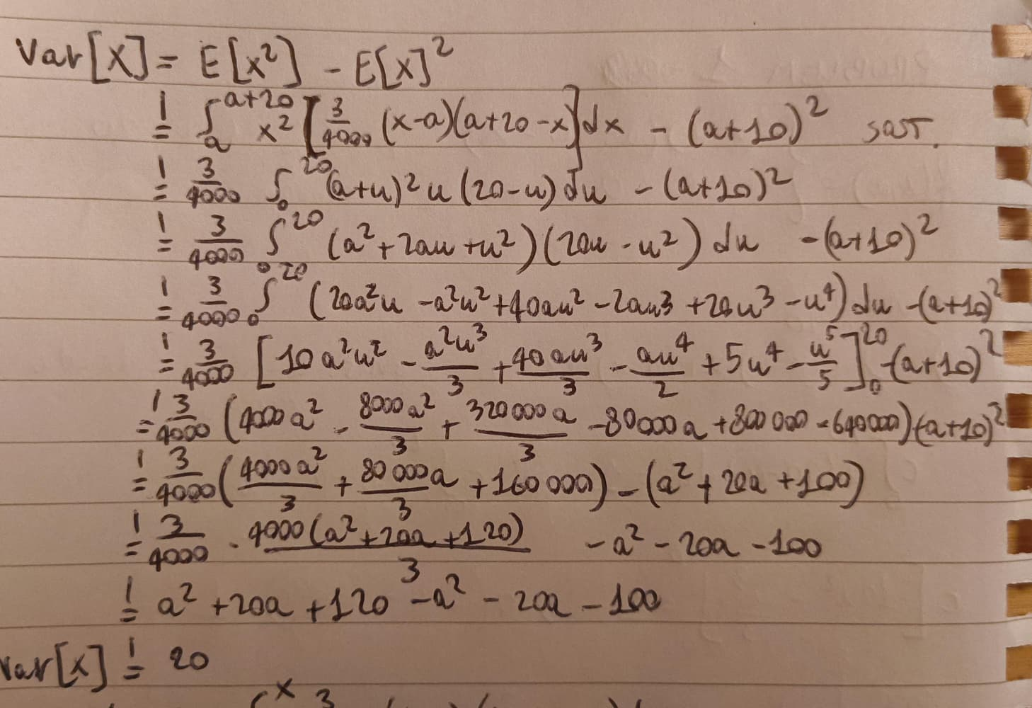

E[X] = a+10 means that a + 10m/s is the expected daily maximum wind speed during autumn. right in the middle of the minimum and maximum threshold.
Var[X] = 100 means that the daily maximum wind speeds have a spread around their expected value with standard deviation 10m/s.

c) Before a the density is 0. I used the same substitution.
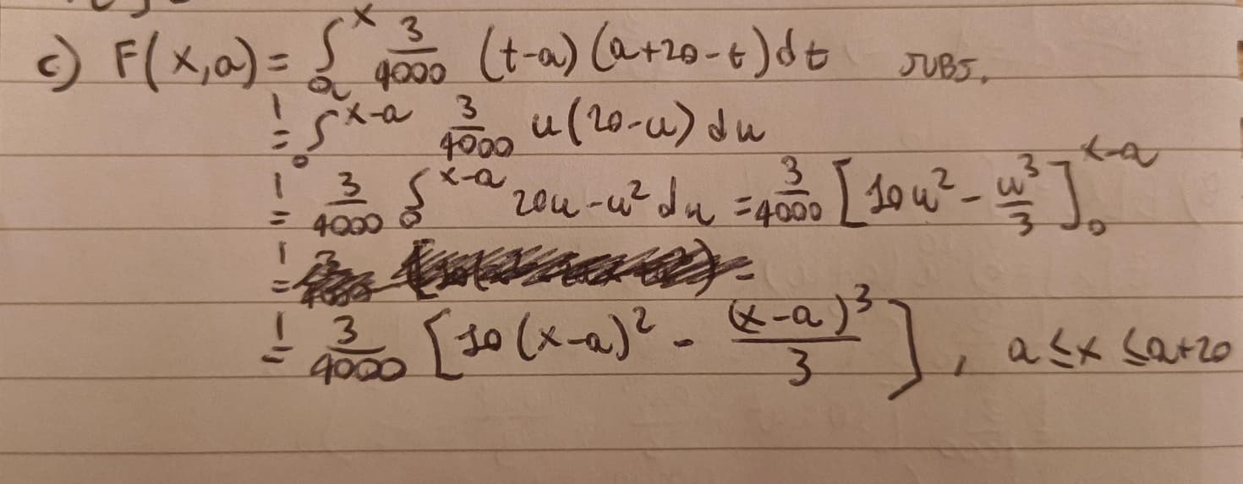
e)
- i) for finding M I used same substitution, and derivatives to find the maximum.
- ii) I calculated the acceptance probability. We generate a candidate Y from a uniform distribution U(a, a+20), then generate U from U(0,1) and accept Y if U is less than the calculated probability, otherwise reject. Repeat until we reach the desired number of sample.
